Lab 1: Ethernet-Based Connection of Network Devices

Step 1: Making an Ethernet Cable Using RJ45 Connectors

Required Equipment:
- Ethernet cable (Cat5e / Cat6)
- RJ45 connectors
- Crimping tool
- Wire stripper
- Network cable tester

Procedure:

A. Straight-Through Ethernet Cable
- Measure and cut the Ethernet cable to the needed length.
- Remove approximately one inch of the outer insulation from both ends.
- Separate and straighten the wire pairs, then arrange them according to the T568B standard:
- Pin configuration (T568B):
1.White-Orange, 2. Orange, 3. White-Green, 4. Blue, 5. White-Blue, 6. Green,
7. White-Brown, 8. Brown
- Trim all wires evenly so they align properly.
- Insert the wires fully into the RJ45 connector while maintaining the correct order.
- Use a crimping tool to firmly attach the connector.
- Repeat the same process on the other end using the identical wiring sequence.
- Verify the cable using a cable tester.

B. Crossover Ethernet Cable
- Cut the Ethernet cable to the required size and strip the outer jacket from both ends.
- Arrange one end of the cable following the T568A standard:
- Pin configuration (T568A):
1.White-Green, 2. Green, 3. White-Orange, 4. Blue, 5. White-Blue, 6. Orange,
7. White-Brown, 8. Brown
- Arrange the other end using the T568B wiring standard.
- Pin configuration (T568B):
1.White-Orange, 2. Orange, 3. White-Green, 4. Blue, 5. White-Blue, 6. Green,
7. White-Brown, 8. Brown
- Ensure all wires are trimmed evenly before insertion.
- Insert the wires into the RJ45 connectors carefully.
- Crimp both ends securely using the crimping tool.
- Test the completed cable using a cable tester to confirm proper crossover connections.

Cable Testing Procedure
- Connect one end of the Ethernet cable to the main unit of the cable tester.
- Attach the opposite end to the remote unit.
- Switch on the tester and monitor the LED indicators.
- Straight-through cables should display continuity from pins 1 to 8 in sequence.
- Crossover cables should show crossed pairs (1↔3 and 2↔6Output: Straight

Output: Straight
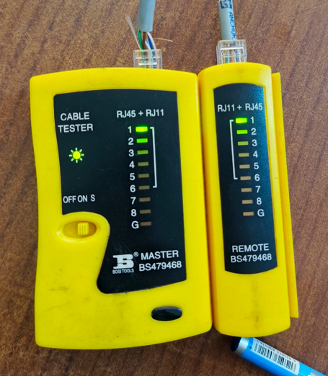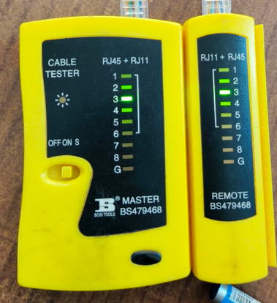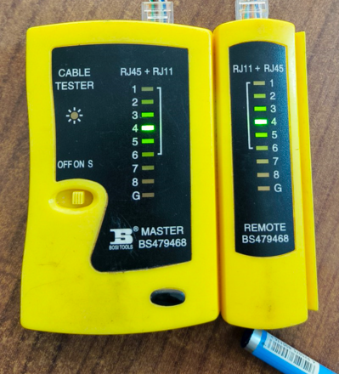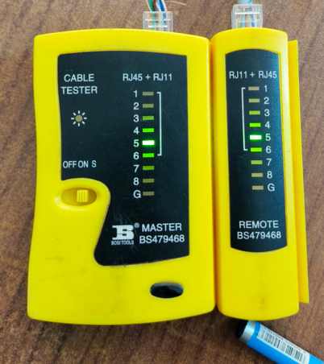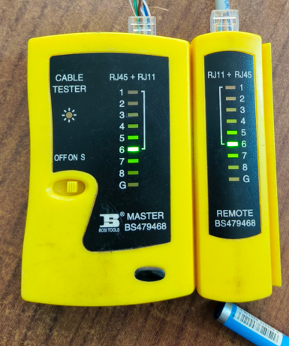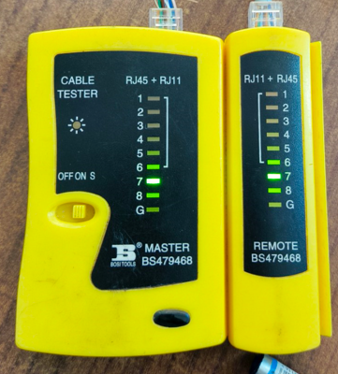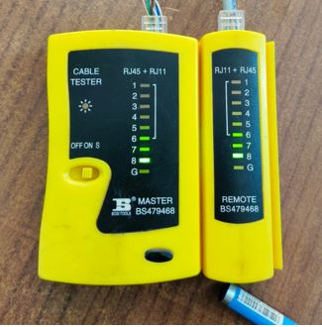

Output: Crossover
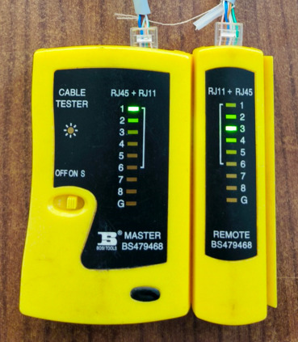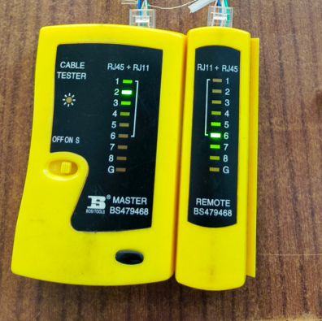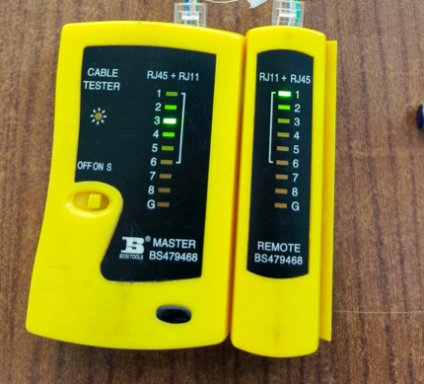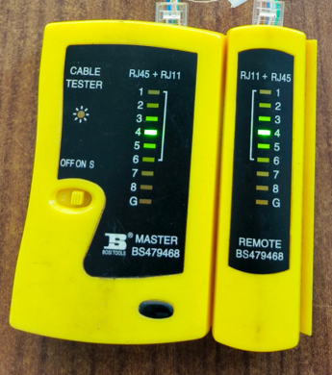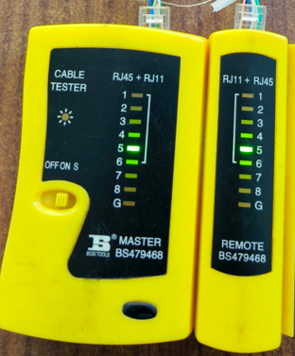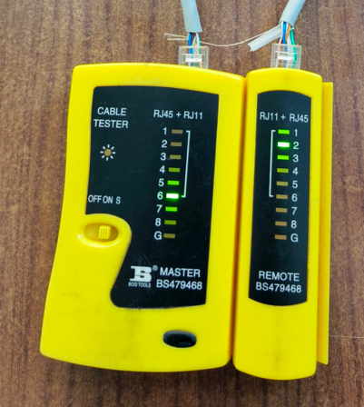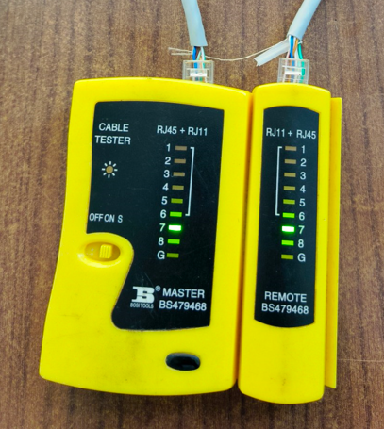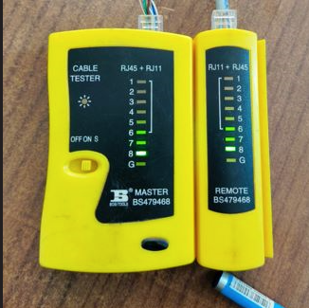

Result
The cable tester confirms correct wiring with no open or short circuits. The observed outputs for straight-through and crossover cables are documented in the respective image folders.

